SAP ARIBA PROCUREMENT PLANNING

Monika Ścipień
04-2026

SAP Ariba Procurement Planning is used to design and structure procurement processes before execution. It allows defining sourcing strategies, organizing stakeholders, and preparing procurement projects in a standardized way.
The project focuses on the creation and planning of procurement initiatives within a structured environment such as SAP Ariba. It begins with defining the planned start of production, which serves as the basis for calculating key project milestones. Based on this timeline, relevant Bill of Materials (BOM) items are assigned to the project.
Subsequently, items are automatically grouped according to their characteristics, enabling more efficient sourcing and process organization. The project schedule is then developed for specific items, including the identification and allocation of required investments.
Finally, selected items are designated for external sourcing and prepared for further activities such as bundling, ensuring an optimized and coordinated procurement process.
- Open Manage Procurement Projects
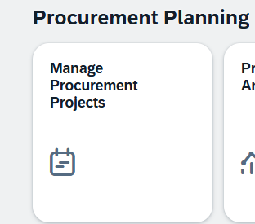
- Click on create
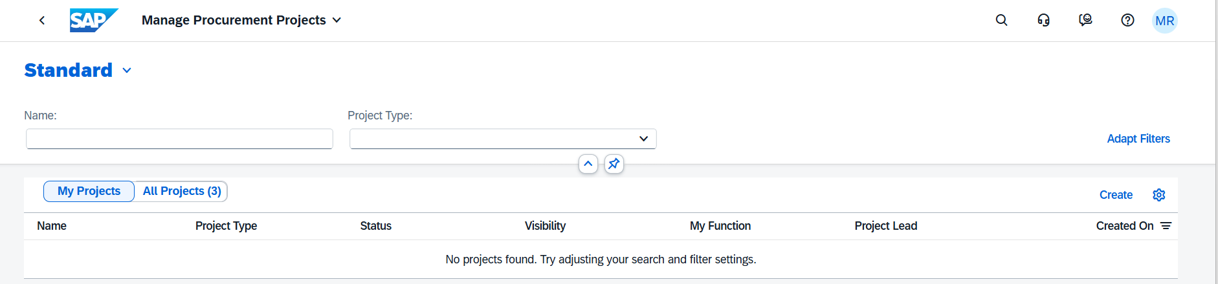
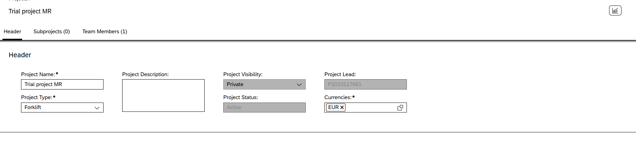
- Choose edit
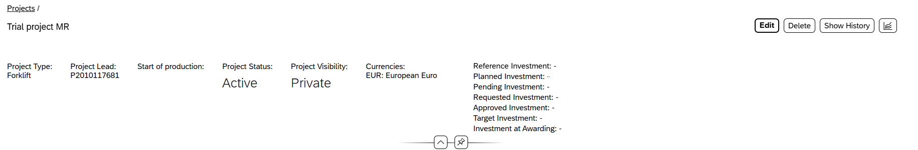
- Change project visibility to public and save it
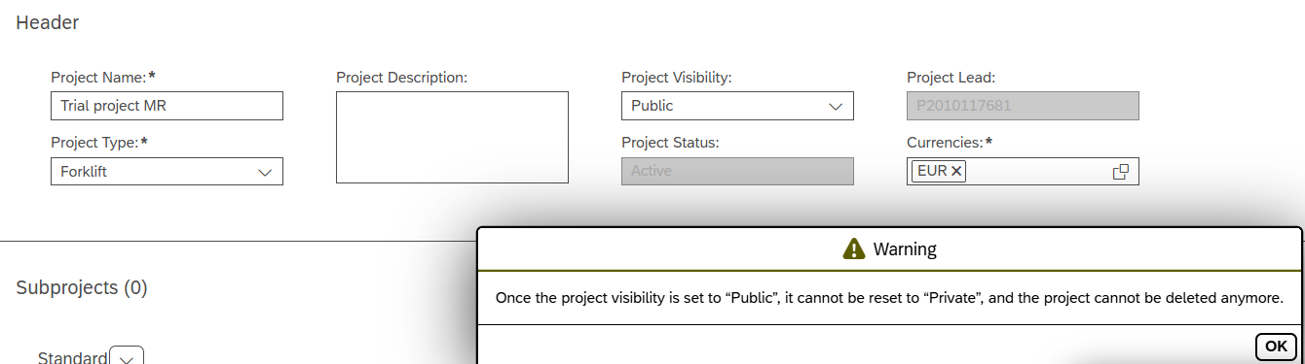
- Choose create
- Enter and choose save
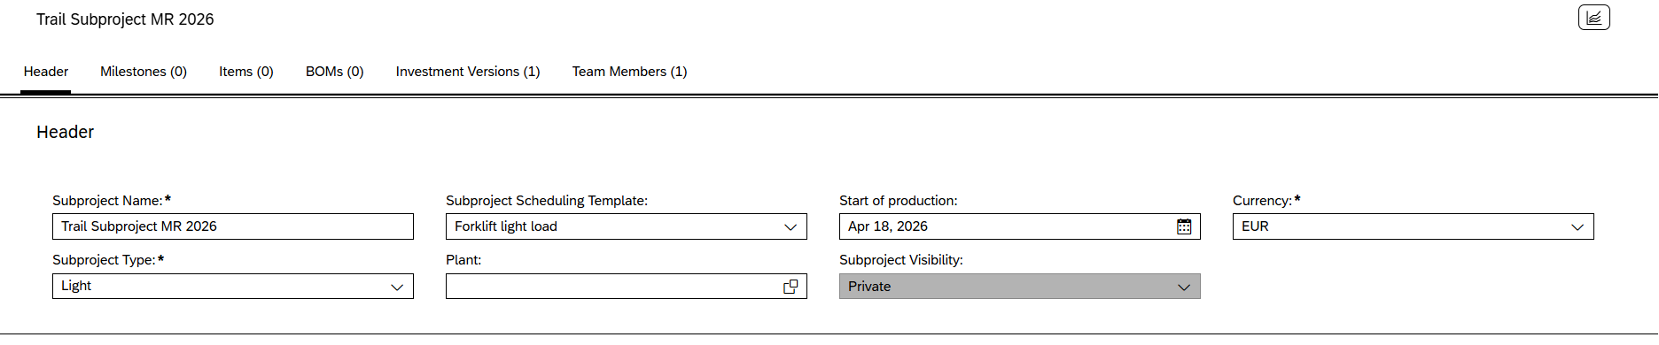
- Choose edit and change visibility to public
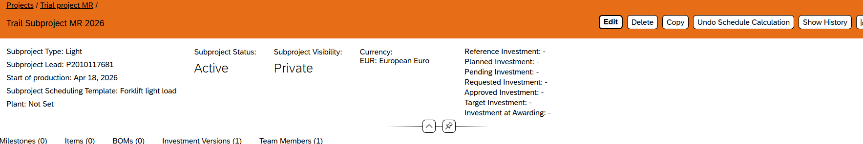
- Choose calculate schedule in milestone section
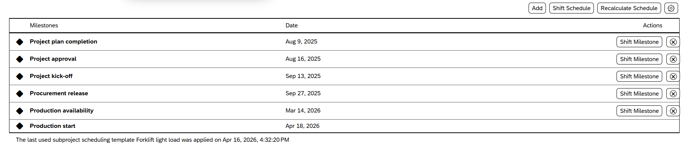
- Go to BOM section and choose add
- Select BOM Forklift
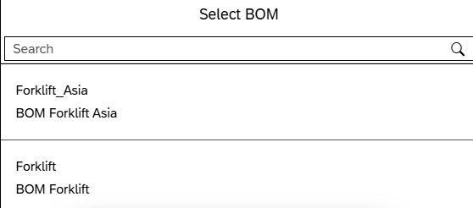
- Choose assign 14 items
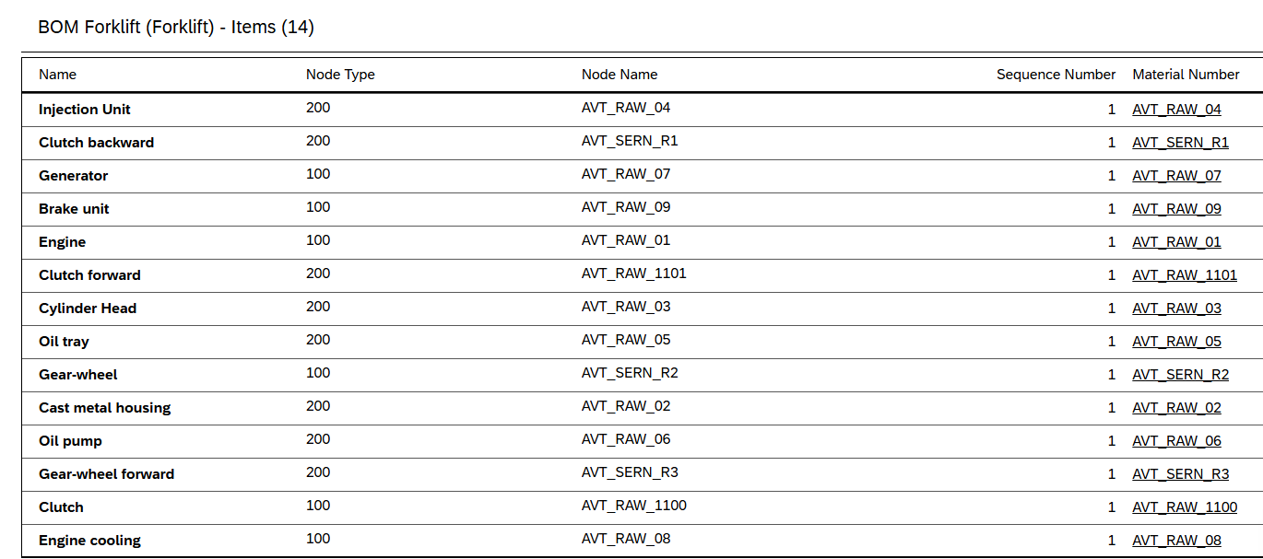

- Go to Items and click on Packages
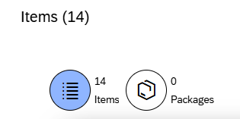
- Choose Assign template
- Choose Package Template Forklift

- Choose Engine and Hydraulics
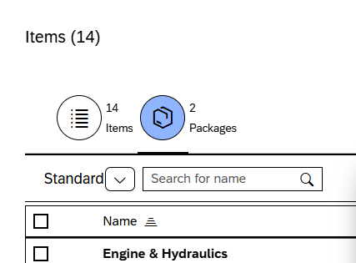
- Choose as below

- Edit options
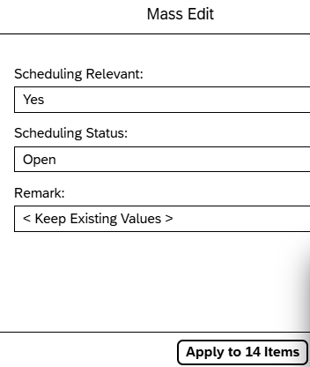
- Choose OK
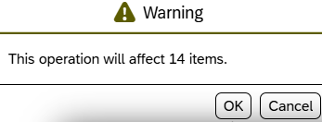
- Open the first item
- Choose Calculate Schedule
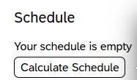
- Check calculated schedule
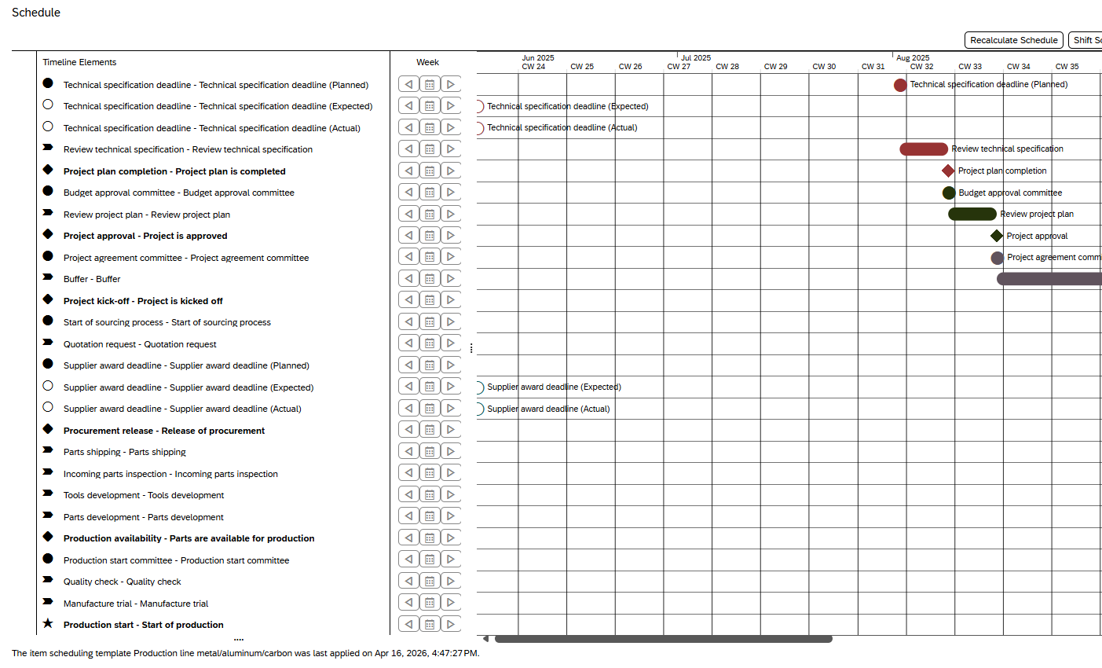
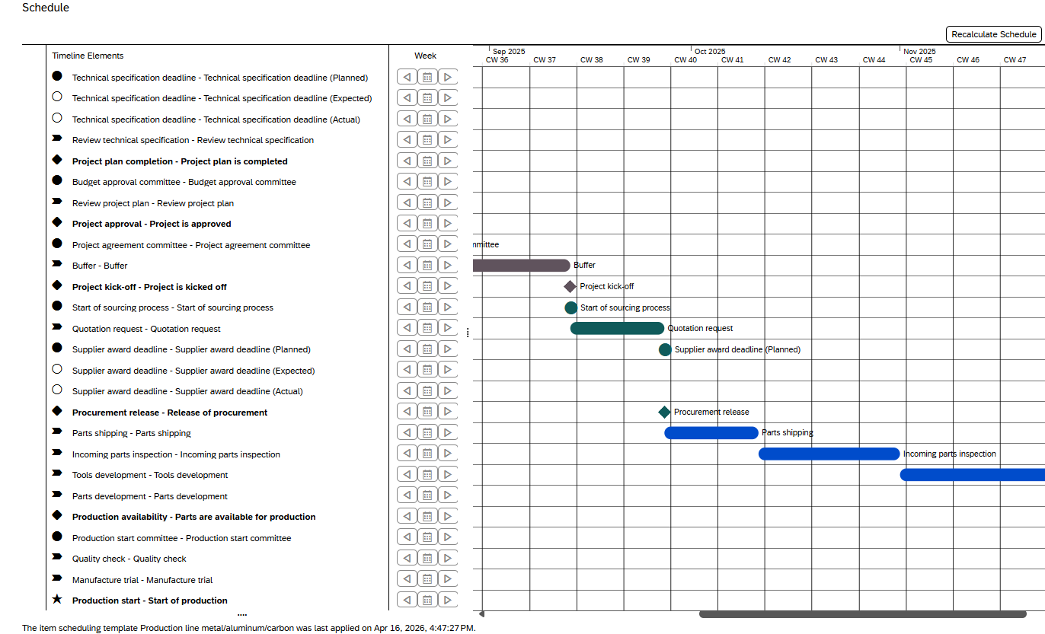
- Choose edit
- Change Investment Relevant to yes and save the data
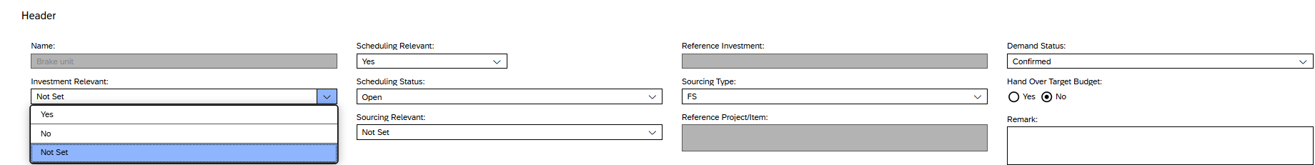
- Choose edit
- Enter the data and save it
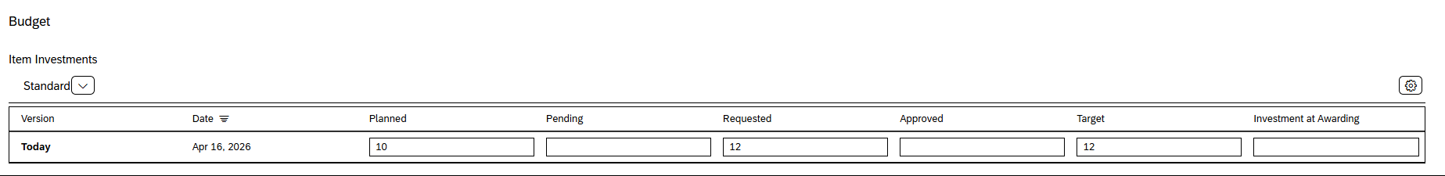
- Go back and click on settings
- Choose views
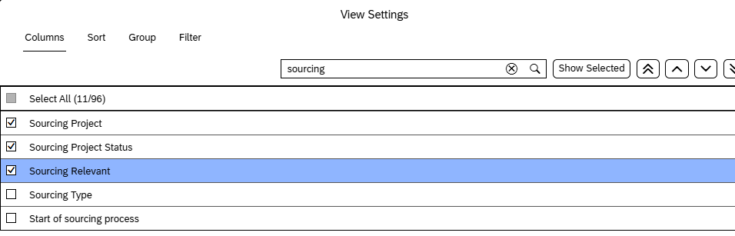
- Choose all items
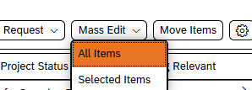
- Choose the filter
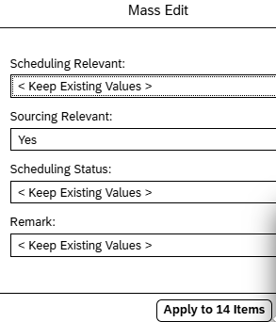
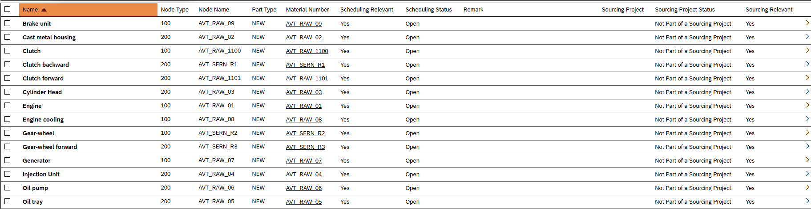

In the next stage, the focus shifts to sourcing preparation. The project items are organized into bundles, which group related items that should be sourced together. This step reflects the role of a sourcing manager and represents the final preparation phase before initiating the sourcing process.
Within this scenario, bundles act as the main business objects, enabling the consolidation of procurement items to improve efficiency and negotiation potential. Two bundles are created and populated with items from the previously defined project structure.
These bundles can later be transferred to systems such as SAP S/4HANA to initiate a formal sourcing project, although this step is beyond the scope of the current exercise.
- Choose manage bundles
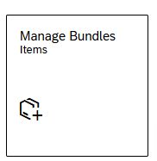
- Choose unassigned items

- Choose project filter

- Choose your project and click on OK
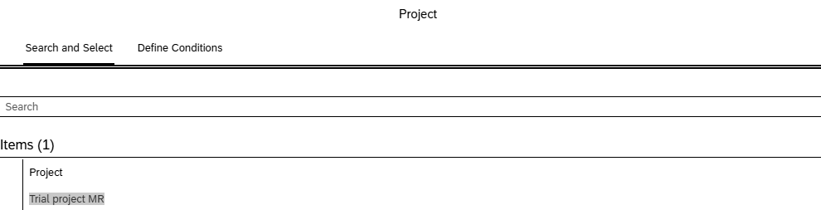

- Click on Go
- Choose Bundle Automatically and all items
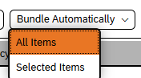
- Select bundling criterion
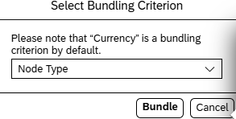
- Choose edit
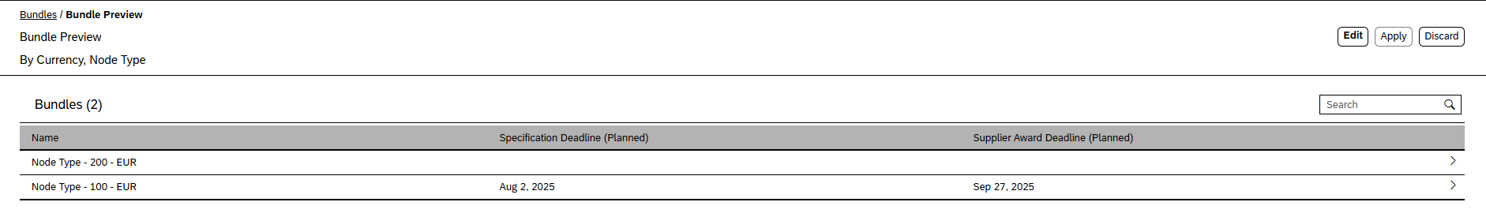
- Enter names and save it
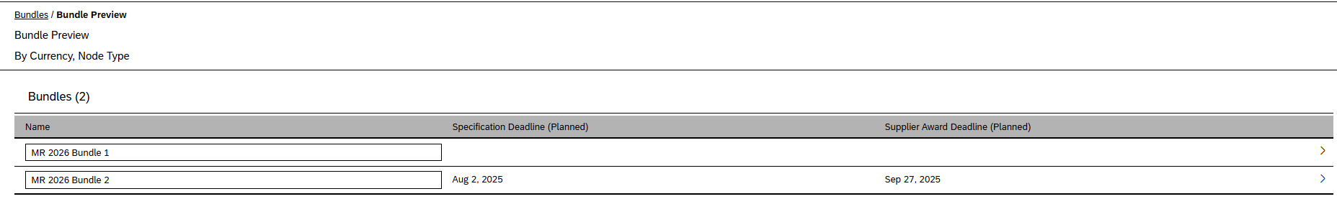
- Apply it
- Choose bundle
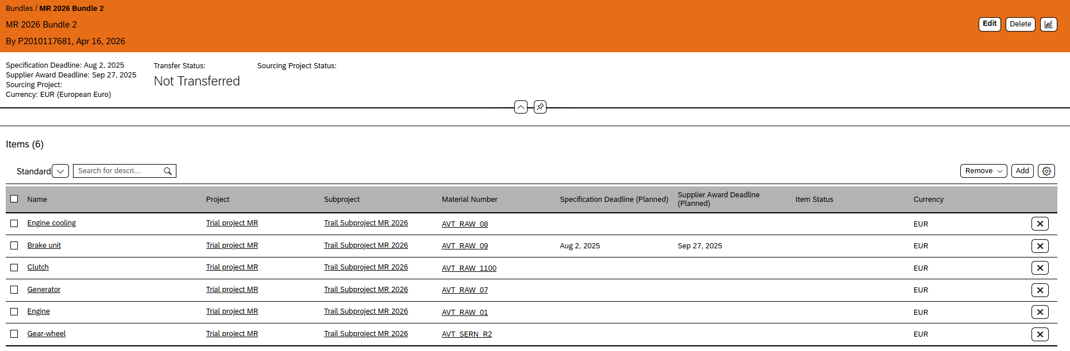
Key milestones, such as the technical specification deadline and supplier award date, were automatically generated based on the predefined schedule of the items.

